

Secure Dev Labs
Ethical Hacking Submission File

Student Information

Student Name | Muhammad Ahmed Raza | Batch | 1st
Internship Track | Ethical Hacking | Week / Task | 1st
Submission Date | 23/04/2026 | Instructor | Muhammad Saad Rajput
Tools Used | Nmap | File Name | Muhammad Ahmed Raza_Lab Setup and Target Enumeration.pdf.

- Task Overview
Task Title: Basic Network Scanning
Task Context: This phase of the project is centered on the architecture of a dedicated virtual laboratory intended for the systematic reconnaissance of a target infrastructure. The process encompasses the validation of network connectivity, the identification of active network nodes, and the detailed enumeration of accessible ports and running services. By doing so, we can effectively map the target's exposure and evaluate the complexity of its potential attack surface.

Objective
The core aim of this task is to deploy a fully operational testing environment, ensure seamless network communication, and execute comprehensive host discovery. Furthermore, the objective is to catalog all exposed services and open ports on the target machine to conduct a rigorous analysis of the security risks they present to the overall system integrity.

Lab Environment and Tools

Item | Details
Operating System | Kali Linux (virtual machine)
Target Machine | Metasploitable 2
Virtualization Tool | Virtual Box
Primary Tool | Nmap
Purpose | Lab setup, host discovery and service enumeration
Scan Command | nmap -sV 192.168.56.102
Target Type | Authorized internal lab target
Evidence | Screenshots are shown below

- Steps Performed

• Environment Setup: Successfully deployed Kali Linux and Metasploitable 2 as virtual instances within VirtualBox, establishing a dedicated NAT network to facilitate secure inter-VM communication.
• Connectivity Validation: Confirmed stable network interaction between the attacker machine (192.168.1.107) and the target system (192.168.1.4) by executing ICMP echo requests via the ping utility.
• Active Host Identification: Conducted a network-wide discovery phase using the nmap -sn 192.168.1.0/24 command to map out all currently reachable devices within the specified subnet.
• Comprehensive Service Mapping: Performed an intensive scan using nmap -sS -p- -sV on the target IP (192.168.1.4) to catalog every open port and determine the specific versions of the services currently exposed.

Evidence Section
Interns should insert clean, relevant screenshots in the same order as the steps above. Do not submit random images without captions.

Figure 1. Metasploitable 2 network setting
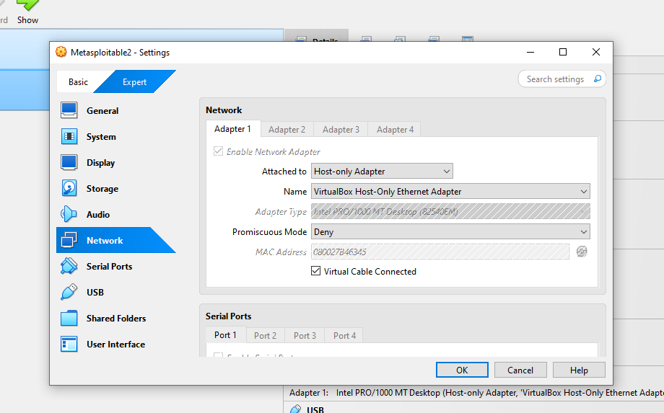

Figure 2. Kali Linux network interface setting

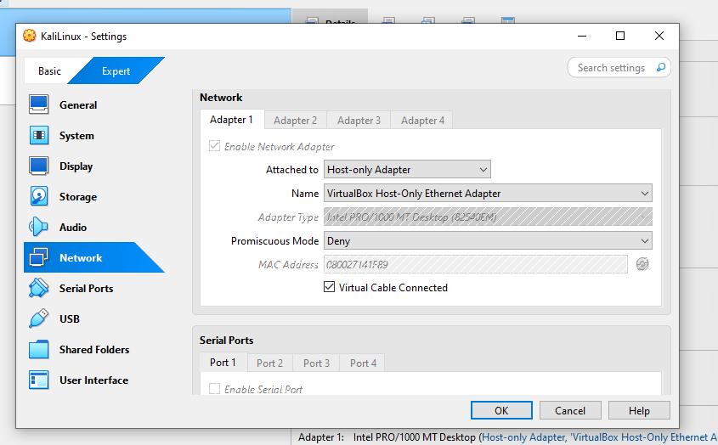

Figure 3. Kali Linux Internal and external connectivity
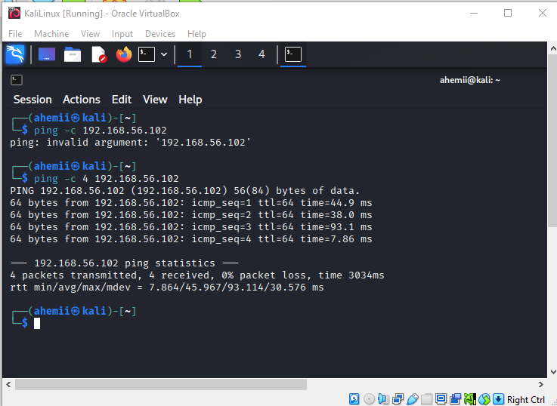
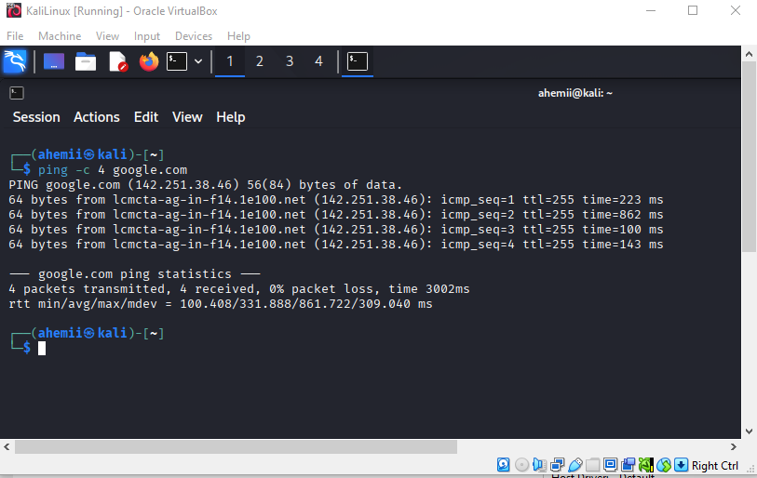

Figure 4. Live Host Enumeration
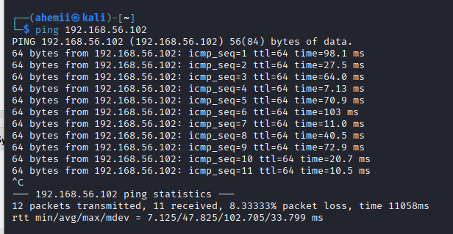
Figure 5. Active ports and Services Enumeration
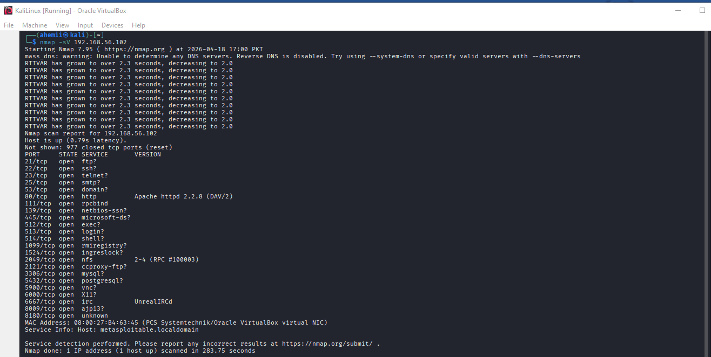

Findings and Analysis

Port | Service | Observation | Possible Risk
21/tcp | FTP (vsftpd 2.3.4) | FTP service is running and accessible | Known backdoor vulnerability in vsftpd  2.3.4 may allow remote access
22/tcp | SSH | Remote login service detected | Weak credentials may allow brute-force attacks
23/tcp | Telnet | Unencrypted remote access service | Credentials can be intercepted easily (plaintext transmission)
25/tcp | SMTP | Mail server is active | Can be used for spam relay or user enumeration
53/tcp | DNS (BIND) | DNS service is exposed | May allow DNS spoofing or zone transfer attacks
80/tcp | HTTP (Apache) | Web server is running | Possible web vulnerabilities (XSS, SQLi, misconfigurations)
111/tcp | RPCBind | RPC service is active | Can expose network services and aid in enumeration
139/tcp | NetBIOS | File sharing service detected | May allow unauthorized access to shared resources
445/tcp | SMB (Samba) | SMB service is running | Vulnerable to SMB exploits (e.g., EternalBlue)
512/tcp | Exec (rexecd) | Remote execution service | Can allow unauthorized command execution

513/tcp | Login (rlogin) | Remote login service | Weak authentication can lead to unauthorized access
514/tcp | tcpwrapped | Service is filtered/protected | May still indicate hidden or restricted services
1099/tcp | Java RMI | Java remote method invocation service | Can be exploited for remote code execution
1524/tcp | Bind Shell | Root shell service detected | Direct root access without authentication (critical vulnerability)
2049/tcp | NFS | Network file system service | Unauthorized file access or data leakage
2121/tcp | FTP (ProFTPD) | Secondary FTP service detected | May contain misconfigurations or weak authentication
3306/tcp | MySQL | Database service is running | Weak credentials may expose sensitive data
3632/tcp | Distccd | Distributed compiler service | Known RCE vulnerability in older versions
5432/tcp | PostgreSQL | Database service detected | Unauthorized access may expose database contents
5900/tcp | VNC | Remote desktop service | Weak/no authentication can allow full system access
6000/tcp | X11 | Display server detected | Can allow remote GUI access if misconfigured
6667/tcp | IRC | IRC service is running | May be used for botnet communication

6697/tcp | IRC (SSL) | Secure IRC service detected | Still may allow unauthorized communication channels
8009/tcp | AJP13 | Apache JServ protocol | Vulnerable to Ghostcat attack (file inclusion)
8180/tcp | HTTP (Tomcat) | Application server detected | Default credentials or misconfigurations possible
8787/tcp | DRb (Ruby) | Ruby distributed object service | May allow remote code execution
39633/tcp | Mountd | NFS mount service | Can expose file system access
43192/tcp | Java RMI | Secondary RMI service | Potential RCE attack vector
43259/tcp | Nlockmgr | Network lock manager | Can be used in NFS- related attacks
53294/tcp | Status | RPC status service | Provides system information useful for attackers

Short Conclusion
Analysis of the scan data indicates a critical lack of security hardening on the target system. By exposing a wide array of services like SMB, RPC, and vsftpd, the system's attack surface has been significantly widened. The discovery of a bind shell on port 1524 is a definitive 'red flag,' indicating a likely prior compromise or a severe configuration flaw. These findings suggest that the target lacks basic defense-in-depth measures, making it an easy target for remote exploitation. We can conclude that the system's current security posture is inadequate against even basic automated attack vectors.

